Install the Interbase ODBC Driver.
- Obtain the database install file called ibwin32setup.zip
- Place the file on your hard drive in a temporary directory called ibinstall. (i.e. c:\ibinstall)
- Unzip the above mentioned file by double clicking on it from Windows Explorer. The files should be extracted into the above mentioned temporary directory.
Note: Unzip is performed by free software called WinZip. If not already installed, see www.winzip.com
- To begin the install double click on the IBWin32Setup.exe icon as shown below.
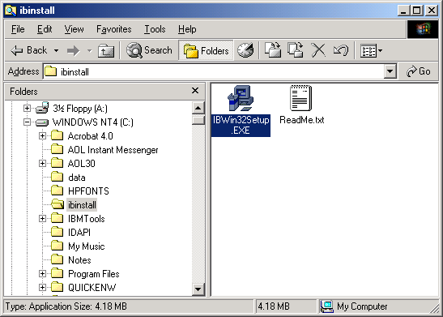
- At the opening dialog choose the Next button to start the install
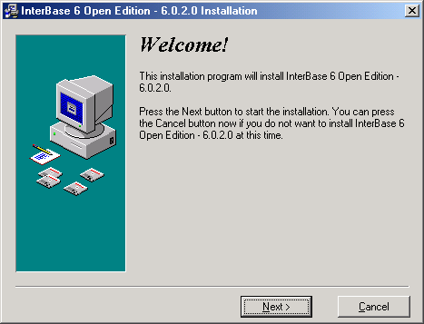
- Next press Agree on the license agreement dialog.
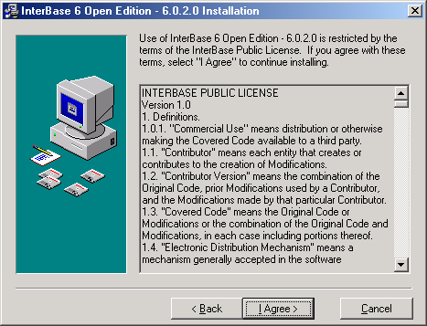
- Leave the default desination folder and press the Next button
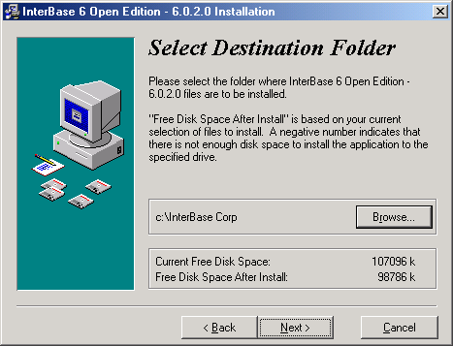
- Select ONLY the components shown below, then press next.
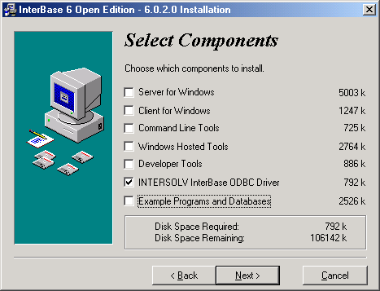
- Begin the install by pressing Next on the following dialog.
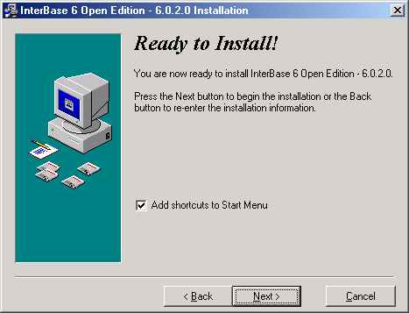
- Leave the defaults on the next dialog and press the Next button to complete the install.
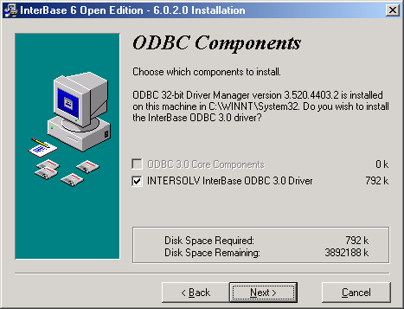
- The install should complete with the following dialog.
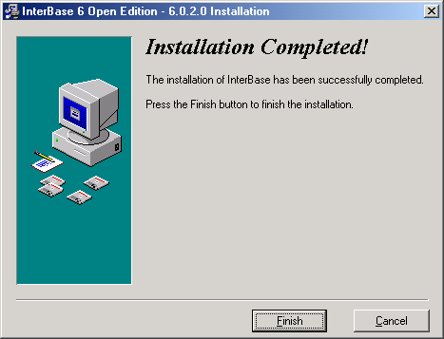

Configure the ODBC Driver
- Begin by opening the Windows control panel as shown below.
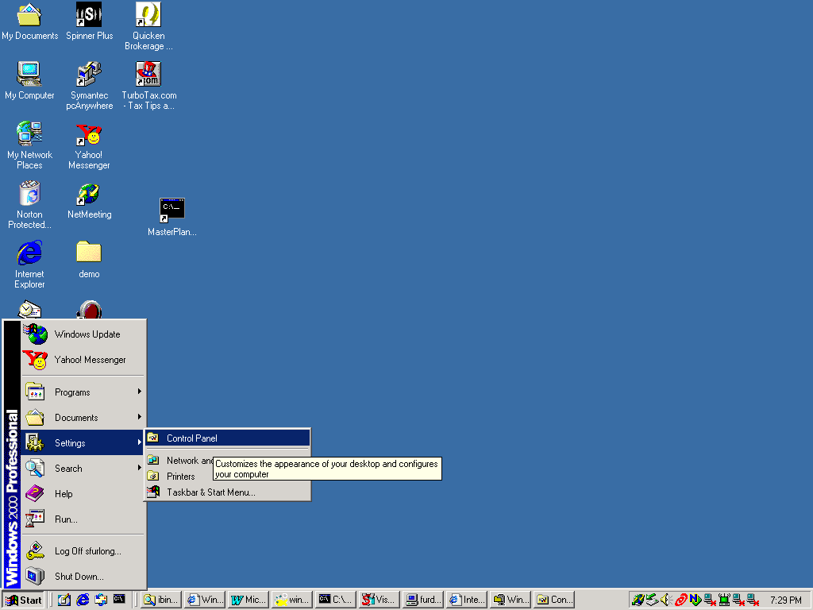
- Next Open the administrative tools applet.
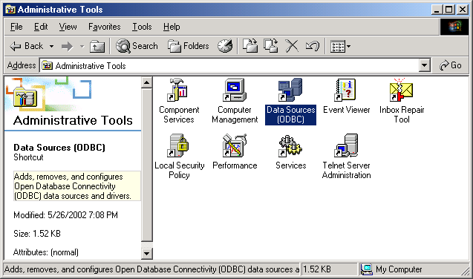
- Click on the User DSN tab of the ODBC Data Source Administrator.
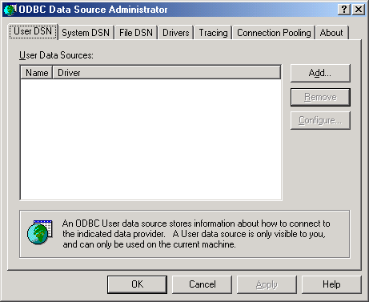
- Press Add and find the INTERSOLV InterBase ODBC Driver (*.gdb). Then select finish.
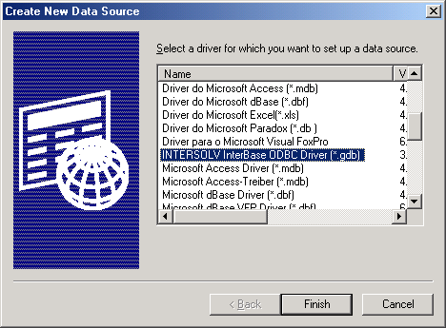
- Set up the next dialog exactly as shown below
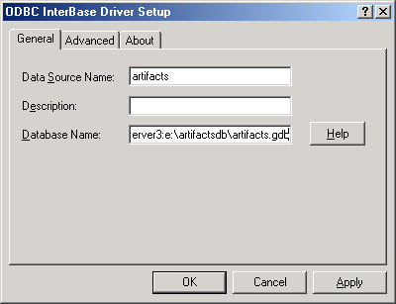
- Next press OK to exit the dialog and OK again to exit the applet.
- Your ODBC driver is now installed.

